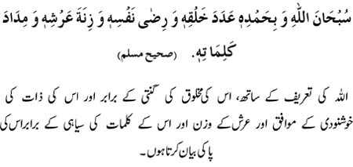
Allah is free from imperfection and I begin with his praise, as many times as the number of His creatures, in accordance with His Good pleasure, equal to the weight of His throne and equal to the ink of His words (that may be used in the recording of His praise)

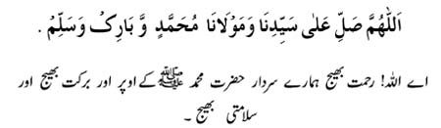
O Allah! Send prayers, blessings and peace on our leader and our Mawla Muhammad(S.A.W).

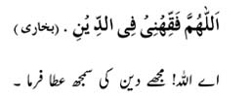
O Allah! Grant me understanding of Deen.
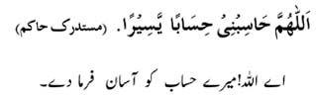
O Allah! Grant me an easy reckoning
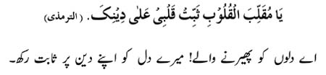
O Allah! The Over-turner of hearts, make my heart steadfast and firm
upon Your Deen.

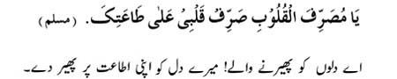
O Allah! The One who turns the hearts, turn my heart towards Your obedience.

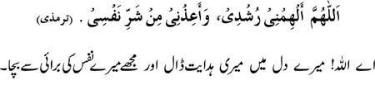
O Allah! Inspire my heart to guidance and save me from the evil of my nafs (soul).

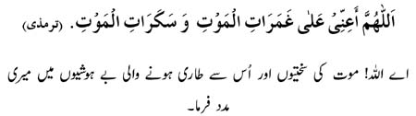
O Allah! Help us in the severity and swoon of death.
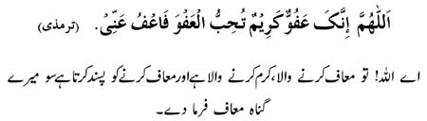
O Allah! You are the One who pardons, The Most Generous; You love to
pardon, so pardon me.

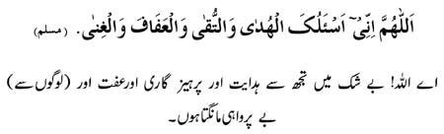
O Allah! Indeed I, I ask of You, guidance and piety and chastity and to be free of depending on anyone (except You).
______________________________________________________________________________
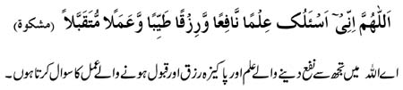
O Allah! I ask you for knowledge which is beneficial, and sustenance which is pure, and deeds which are accepted.
______________________________________________________________________________
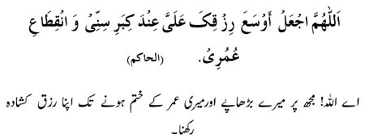
O Allah! Expand for me Your provision till my old age and till the end of my life.
______________________________________________________________________________
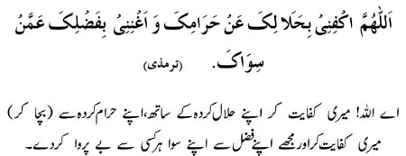
O Allah! Make sufficient for me what is halal (lawful) and to dispense with what is haram (unlawful) and enrich me with Your Favors so that I need no one but You.

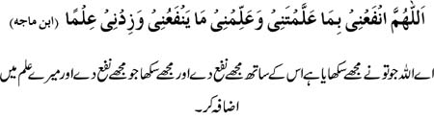
O Allah! Make useful for me what You taught me and teach me knowledge that will be useful to me.

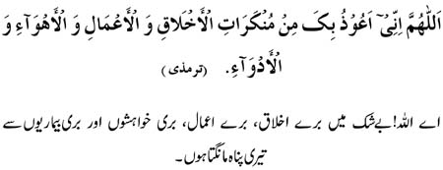
O Allaah! Indeed I, I seek refuge in You from a disliked character & manners and from disliked deeds, desires and illnesses.
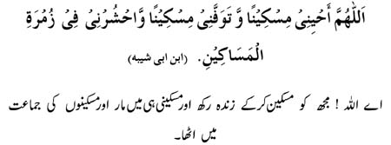
O Allah! Keep me alive (in a state of) humbleness and grant me death in (a state of) humbleness and gather (resurrect) me in the company of the humble ones.

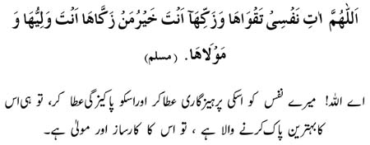
O Allah! Grant my nafs (soul) piety and purify it, for You are The Best of those who purify it as You are its Guardian and Master.

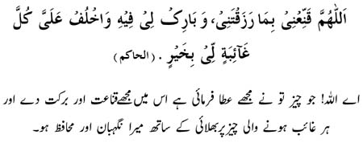
O Allah! Make me content upon what You have granted me and Bless me in it; and be The Best Protector and Guardian for me (in my absence) of whatever is hidden from me.

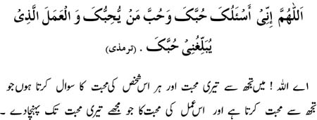
O Allah! I ask of You Your love, the love of whoever loves You and the love of those deeds which would draw me to attaining Your love.

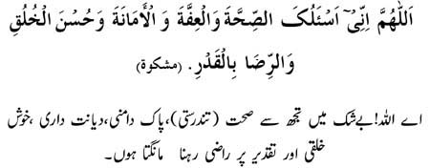
O Allah! Indeed I ask of You, sound health, chastity, trustworthiness, good character and contentment on whatever is decreed.

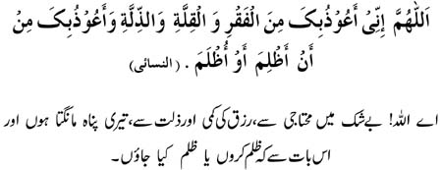
O Allah! Indeed I, I seek refuge in You from poverty, any lessening in my means, and from humiliation; and I seek refuge in You that I wrong anyone or am wronged.

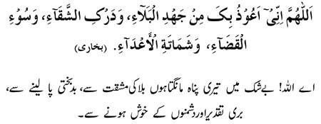
O Allah! Indeed I seek refuge in You from severe trials and hardships, to be overtaken by wretchedness, a bad fate and the rejoicing of _ enemies.

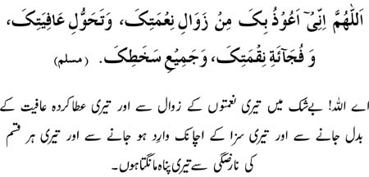
O Allah! I seek refuge in You from the decline of Your blessings, the removal of our state of well-being, the sudden onset of Your punishment and from all that displeases you.

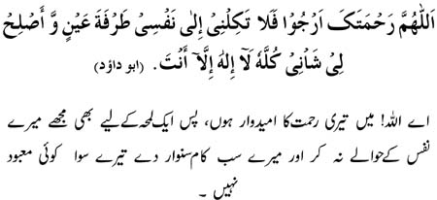
O Allah! In your mercy I return, so do not leave me in charge of my nafs (myself) even for a blink of an eye and rectify for me all of my affairs. There is no god but You.

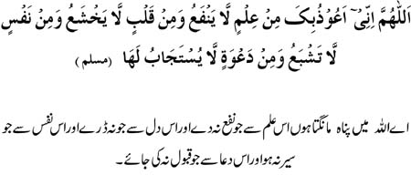
O Allah! I seek refuge in You from a knowledge which does not benefit, from a heart which does not tremble, from a nafs (ego) which is not content (sated), and from a supplication which is not accepted.

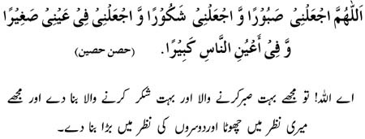
O Allah! Make me one who is most patient and grateful; and make me small in my own eyes but great in the eyes of others.

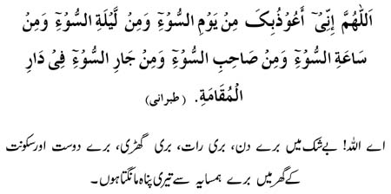
O Allah! Indeed _ I seek refuge in You from an evil day, an evil night, an evil moment, an evil companion and from an evil neighbour in the place of residence.

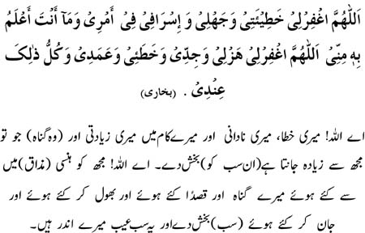
O Allah! Forgive me my faults, my ignorance, any excesses in my matters and in that which You have more knowledge of than me. O Allah! Forgive me my sins done in jest, those done mistakenly, those done intentionally and all those shortcomings that are within me.

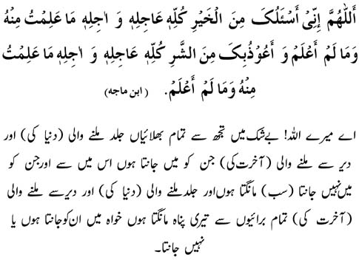
O Allah! Indeed I ask You of every kind of good, the one to be hastened (of the world) and the one to be delayed (of the hereafter) from that which I know and do not know; and I seek refuge in You from every kind of evil the one to be hastened (of the world) and the one to be delayed (of the hereafter) from that which I know and do not know.

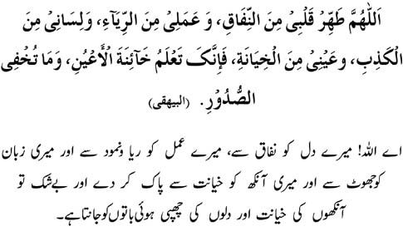
O Allah! Purify my heart from hypocrisy, my deeds from any kind of Ria (boasting), my tongue from lying and my eye from treachery. For indeed only You know the treachery of the eyes and what lays hidden in the breasts.

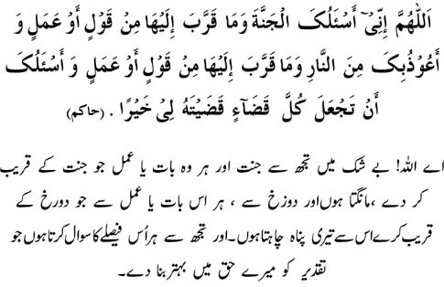
O Allah! Indeed I ask You of Paradise and of every deed or speech that will be a means of drawing near to it; and I seek refuge in You from the fire and from every deed or speech that will be a means of drawing near to it; and I ask You that You make whatever You have decreed for me a means of good.

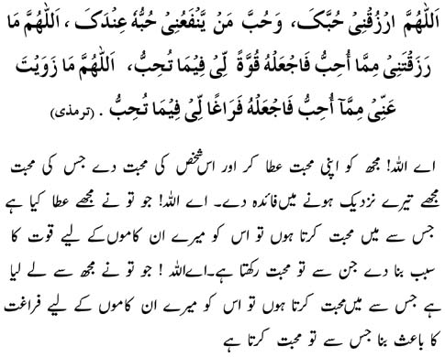
O Allah! Grant me Your love, and the love of a person whom my loving him will benefit me draw closer to You. O Allah! Whatever You have granted me from what I love, make it a means of strength for me to use in the way You love. O Allah! Whatever love (of things) You have removed from me then Grant in its place the love (of things) that You love.

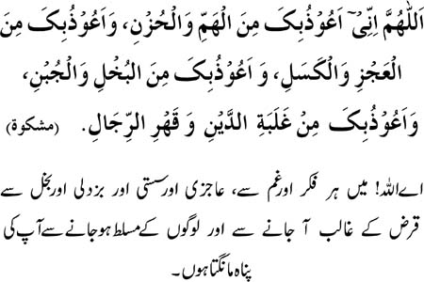
O Allah! I take refuge in You from anxiety and sorrow, and I seek refuge from weakness and laziness. And I seek refuge from miserliness and cowardice, and I seek refuge from the burden of debts and from being over powered by men.

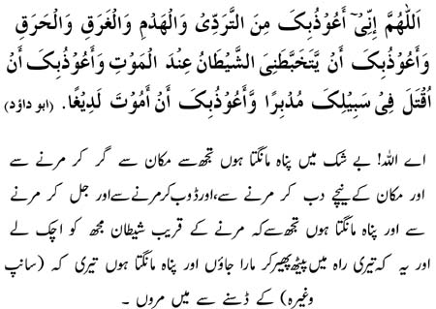
O Allah! Indeed I seek refuge in You from death caused by falling from a building, or being buried under its debris, from death by drowning, or from burning to death, and I seek refuge in You that Satan should confound me near death and that I should die in your way while turning my back (fleeing); and I seek refuge in You that I should die from the bite of a venomous animal

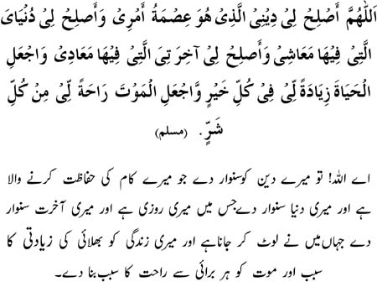
O Allah! Rectify for me my Deen which is a means of guarding my matters and the world which is a means of my livelihood, and make good my hereafter in which is my returning, and make my life a means of abundance of good and my death a means of comfort and peace free of all bad.

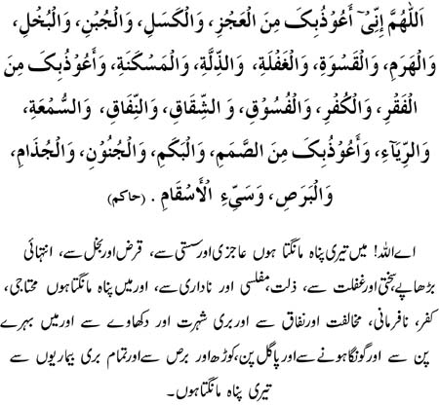
O Allah I seek refuge in You from inaction / inability _
(to do good ), _ laziness, _ cowardice, _ miserliness, _ senility (weakness of old age), a hard heart (being harsh), heedlessness, humiliation, destitution and I seek refuge in you from poverty, disbelief, disobedience, opposition, hypocrisy, bad reputation and showing off, I seek refuge in You from deafness, dumbness, insanity, leucoderma , leprosy, and from all bad diseases.

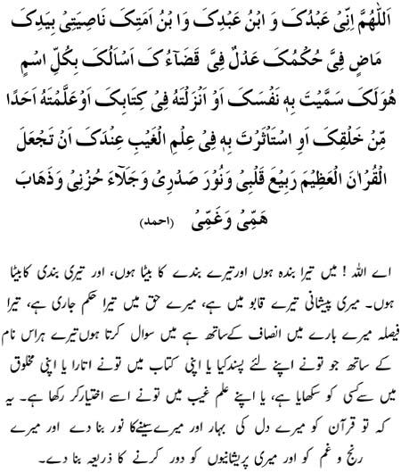
O Allah! Indeed I am Your slave, the son of Your slave, son of Your bondwoman, my forelock is in Your Hand, Your decrees are bound to prevail on me and Your decree over me is just. I ask You by every name belonging to You which You named Yourself with, or revealed in Your Book, or You taught to any of Your creation, or You have preserved in the knowledge of the unseen with You, that You make the great Quran the life of my heart and the light of my breast, and the departure of my sorrow and a release of my anxiety and depression

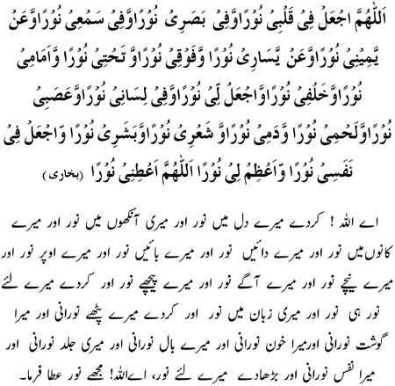
O Allah! Put light in my heart, and light in my sight, and light in my hearing, and light to my right and light to my left, and light below me, and light above me, and light before of me and light behind me, and make light for me, and light in my tongue and light in my muscles and light in my flesh, and light in my blood, and light in my hair, and light in my body and light in my soul; and magnify the light for me. _ O Allah! bestow me with light

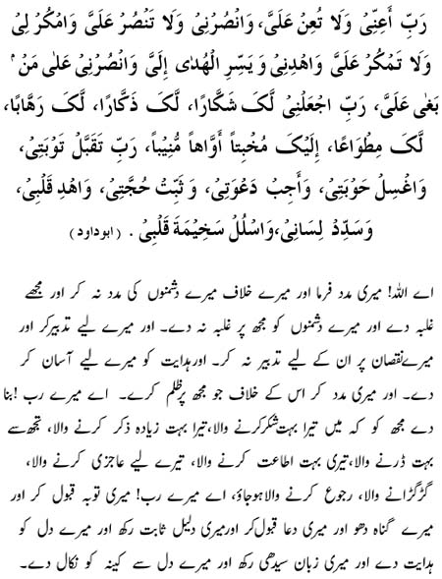
O My Lord! Help me and do not help (others) against me, help me to overpower (them) and do not let them overpower me, plan in my favor and do not plan against me, guide me and make the Guidance easy for me, and help me against whoever oppresses me; O my Lord! Make me one most grateful to You, one who mentions Your name greatly, one who fears You greatly, one who obeys You greatly, one turning greatly in submission and humility towards You; O my Lord! Accept my repentance, wash away my sins, accept my invocations, keep me firm on my proof, guide my heart, make my tongue to utter what is correct and true, and remove any ill will and rancor from my heart.

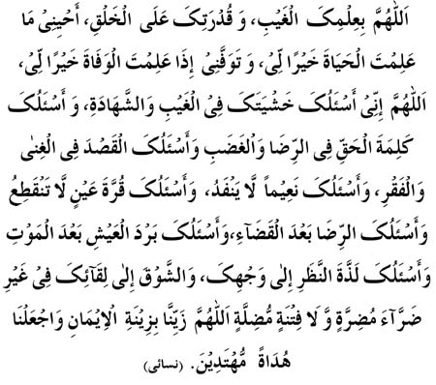
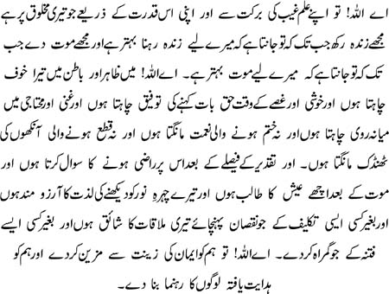
O Allah! By Your knowledge of the unseen, and by Your power over Your creation, keep me alive as long as you know that life is good for me, and give me death when you know that death is good for me. O Allah, I beseech you for Your fear in the absent and the present and I beseech You for the ability to speak the truth in contentment and in anger and I ask you for moderation in wealth and poverty and never-ending blessings and unceasing coolness of the eyes and I ask You for contentment after you have decree and the pleasure of life after death and I ask You for the delight of gazing at Your Countenance and the eagerness of meeting You without any difficulty that may harm or any trial that may mislead. O Allah! Adorn us with the beauty of faith and make us a guider of the guided ones.

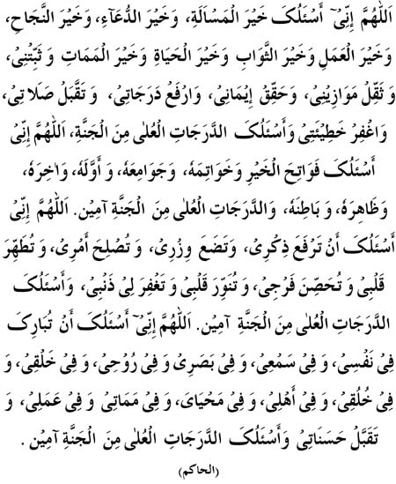
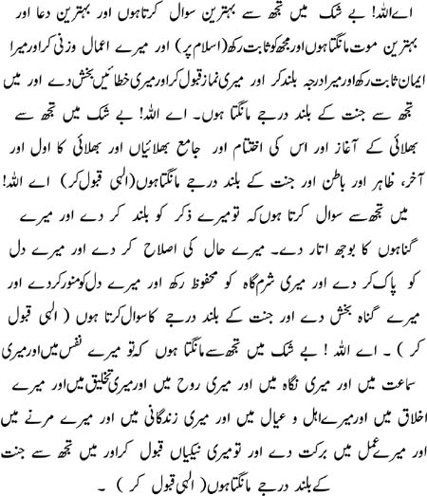
O Allah! Indeed I ask of you the best appeal and the best of invocation and an excellent success and the best deed and the best recompense and the best life and the best death and make me steadfast (on my Deen) and make heavy my scale (of good deeds) and make my faith a reality and elevate my ranks and accept my prayers and forgive my mistakes. And I beseech You for the highest levels of paradise _ .O Allah! Indeed I implore You for the opening of good ways _ and it's achievements too and it's entirety, and it's first and it's last and it's apparent and it's hidden (with it's true spirit) and the highest levels of paradise. 'Ameen (Allah accept my prayer). O Allah! Indeed I implore You that You elevate my dhikr (mention) and You unload my burden (of sins, work, unwanted things) and You reform my condition and You purify my heart (from enmity, jealousy, cowardice, laziness, miserliness and all bad) and You safeguard my private parts and You illuminate my heart and You forgive my sins and I beseech You for the highest levels of paradise. 'Ameen. _ O Allah! Indeed I implore You that You bless my nafs (self), and my hearing and my sight and my soul and my (physical) self and my character and my family and my life and my death and my deeds and accept my good deeds and I beseech You for the highest levels of Paradise. _ 'Ameen.

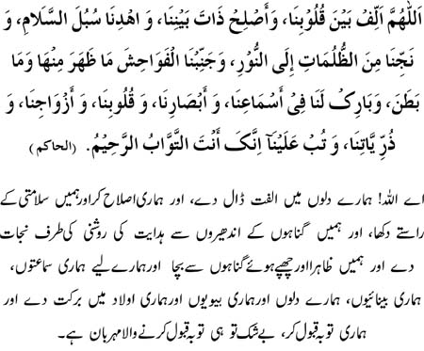
O Allah! Put affection amongst our hearts, Set right our matters between ourselves, Guide us to the ways of peace, Deliver us from darkness towards light, Save us from all kinds of indecency; the apparent as well as the hidden, and Bless our hearing, our seeing, our hearts, our spouses and our children, and Accept our repentance. Indeed You are the One who greatly Accepts repentance, One who is repeatedly Merciful.

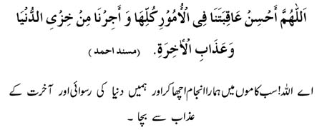
O Allah! Grant a good end to all our matters and save us from humiliation in the world and the punishment of the Hereafter.

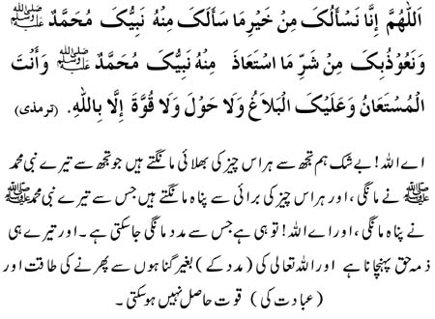
O Allah! Indeed we ask You of all good that Your Prophet Muhammad (SAW) asked You of, and we seek refuge in You from all bad that Your Prophet Muhammad (SAW) sought refuge from. You are The One whose Help is sought and The One to make it reach (us); there is no Power and Strength except with Allah.

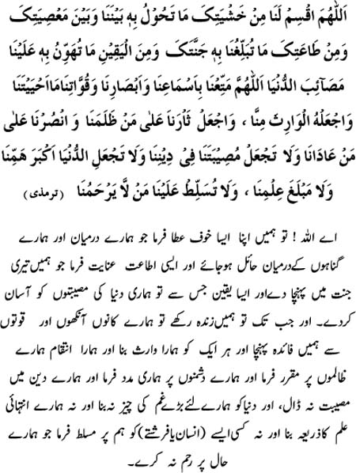
O Allah distribute amongst us such awe and fear of You that will be a means of intervening between us and Your disobedience; and grant us such obedience to You that will enable us to reach Your Paradise; and such conviction which will ease out upon us the afflictions of the world . O Allah, 'as long as' You give us life, benefit us by means of _ our hearing, our sight and our bodily strength / faculties and make each one of them our inheritor; and avenge for us those who wronged us and help us against our enemies; and do not place any difficulties in our deen, nor make the world the greatest of our sorrows (worries) nor the limit of the source of our knowledge; and do not impose upon us one who has no mercy for us.

